***52.3***

#include <stdio.h>

int main()

{

printf("The result are %f %f %f" ,3.0*5.0,7.1*8.3-2.2,3.1/(6.1*5));

return 0;

}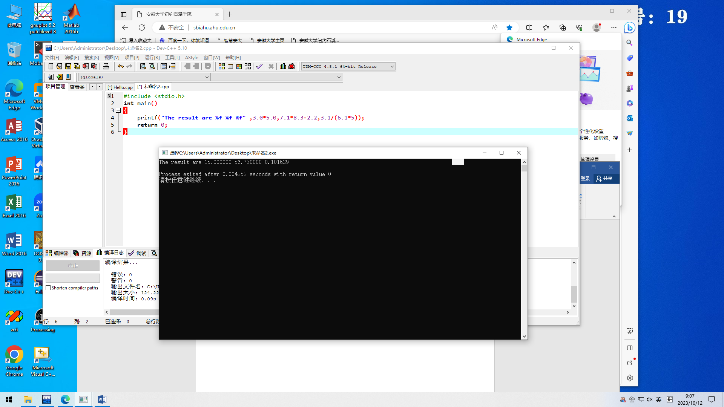

***52.4***

#include <stdio.h>

int main()

{

printf("%d,%d,%d,",15/4,15%4,5*3-(6*4));

} 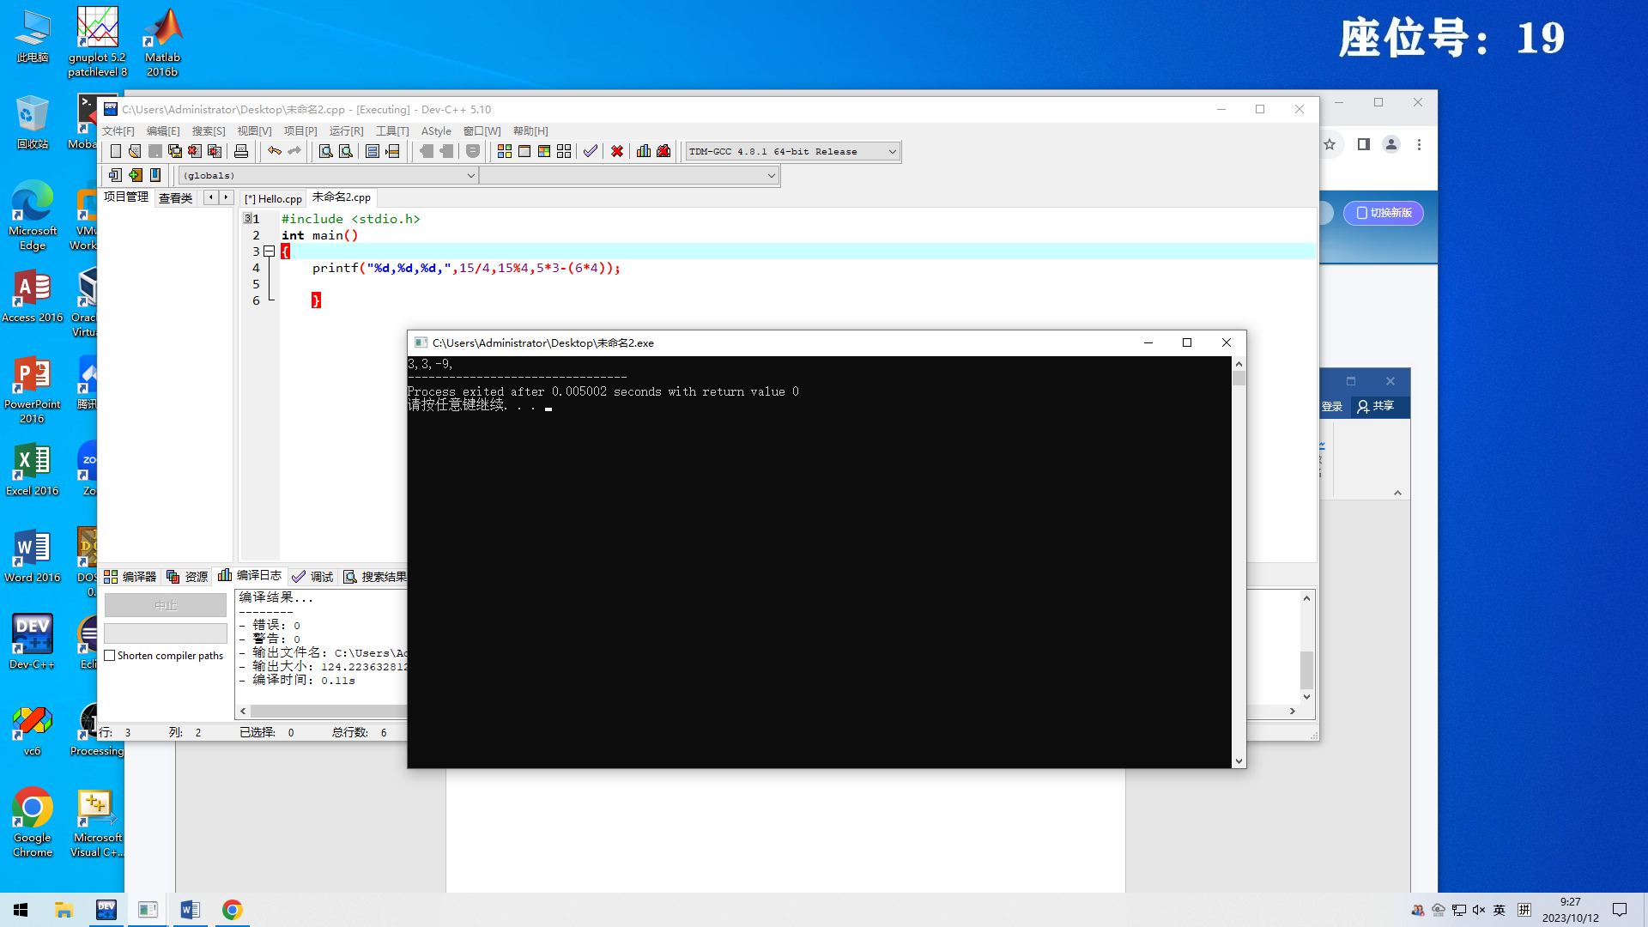

***52.5***

#include <stdio.h>

int main()

{

printf("%d,%d,%d,",'a','m','n');

} 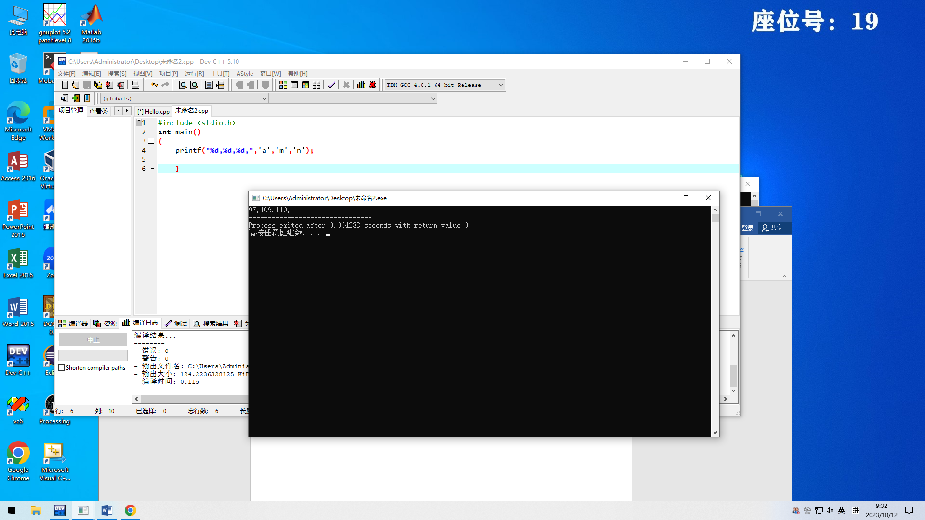

***52.6***

#include <stdio.h>

#include <limits.h>

int main()

{

printf("The smallest integer value that can be stored is %d\n",INT_MIN);

printf("The largest onteger value thatcan be stored is %d\n",INT_MAX);

return 0;

}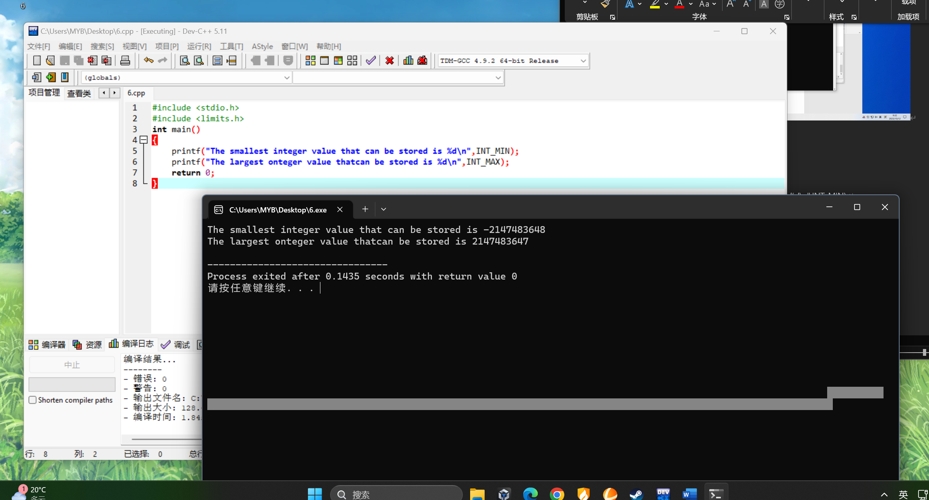

***60.2***

#include <stdio.h>

#include <math.h>

int main()

{

float radius=2.57;

float PI=3.1216;

printf("area=%f",PI*radius*radius);

return 0;

}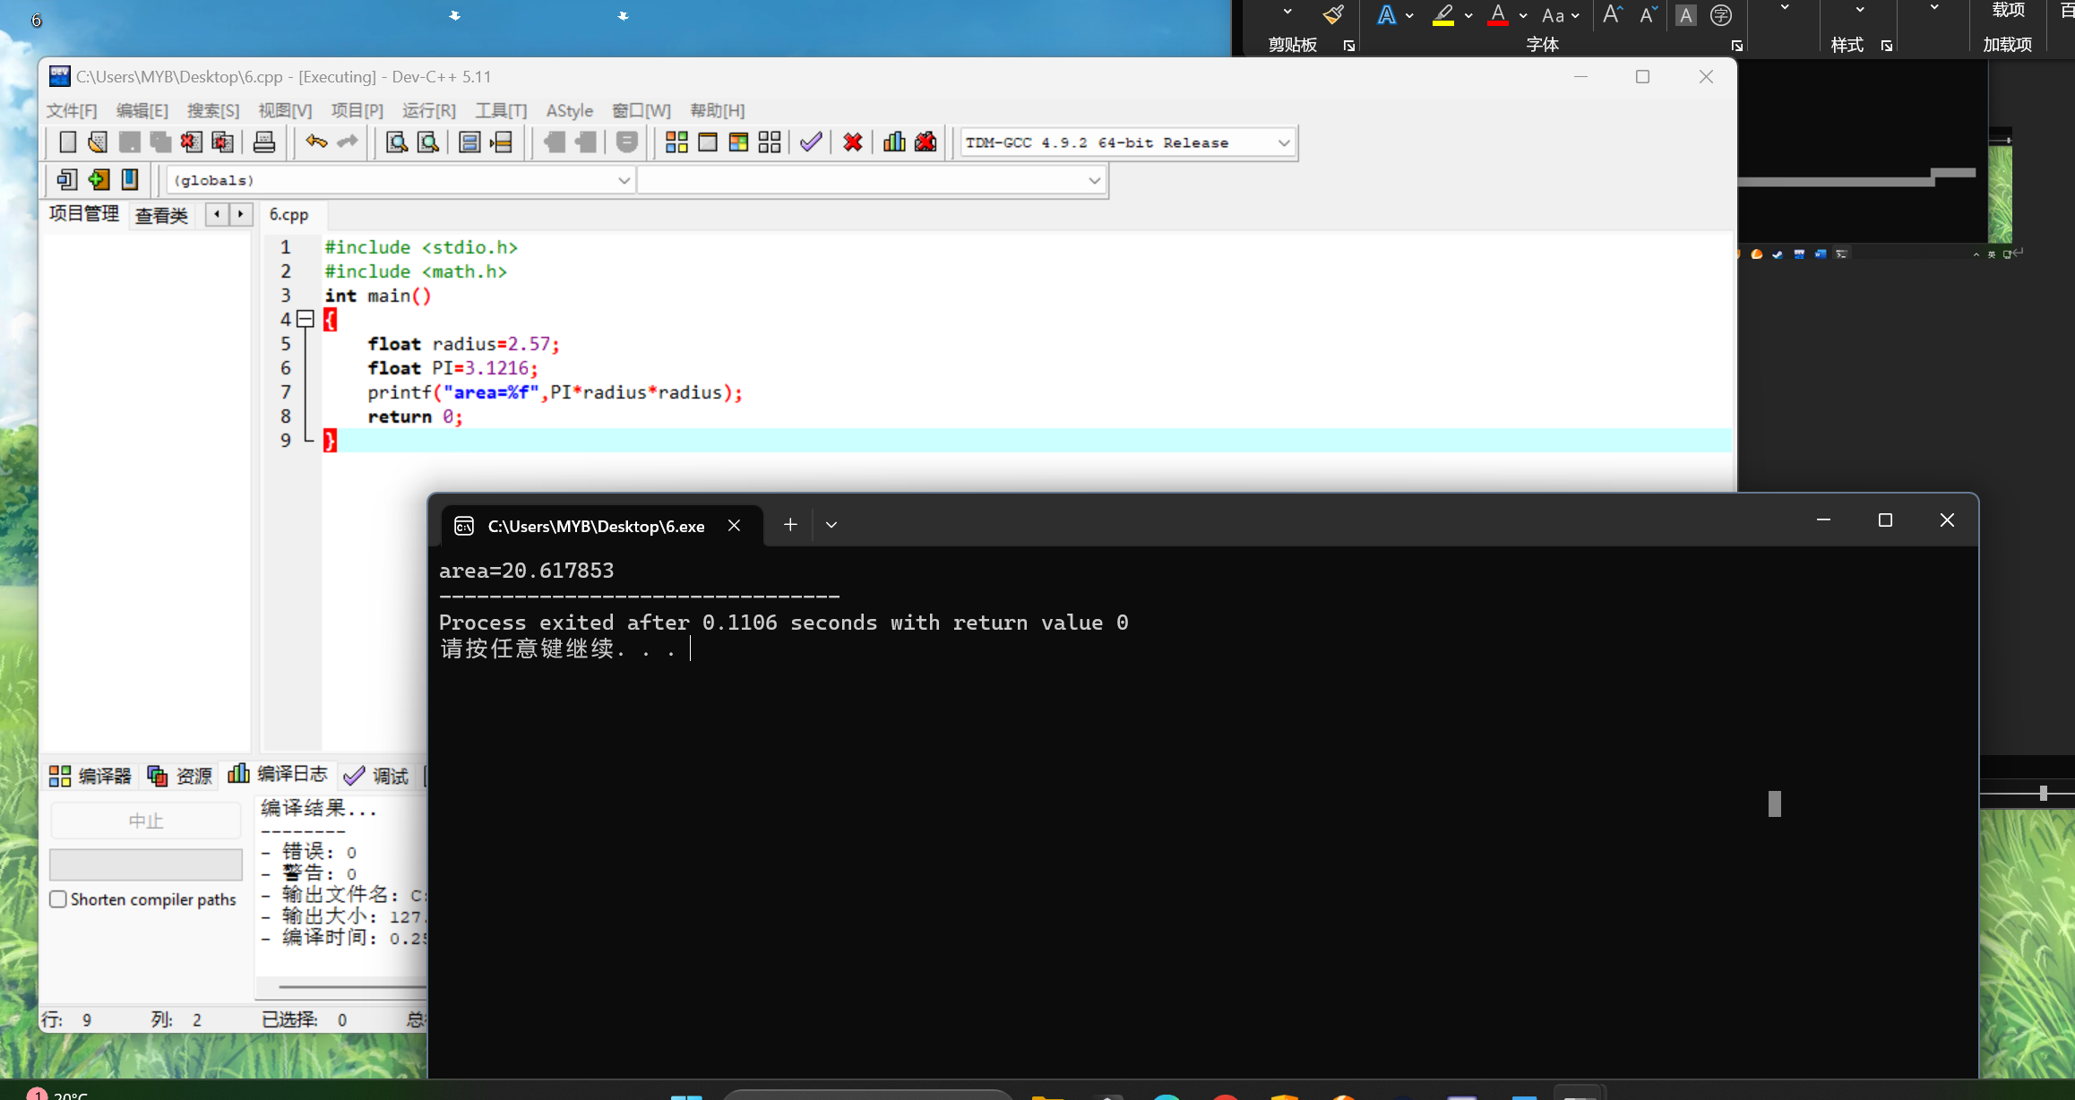

***60.3.a***

#include <stdio.h>

int main()

{

float width=3.5,length=5.48;

printf("area=%f",width*length);

return 0;

}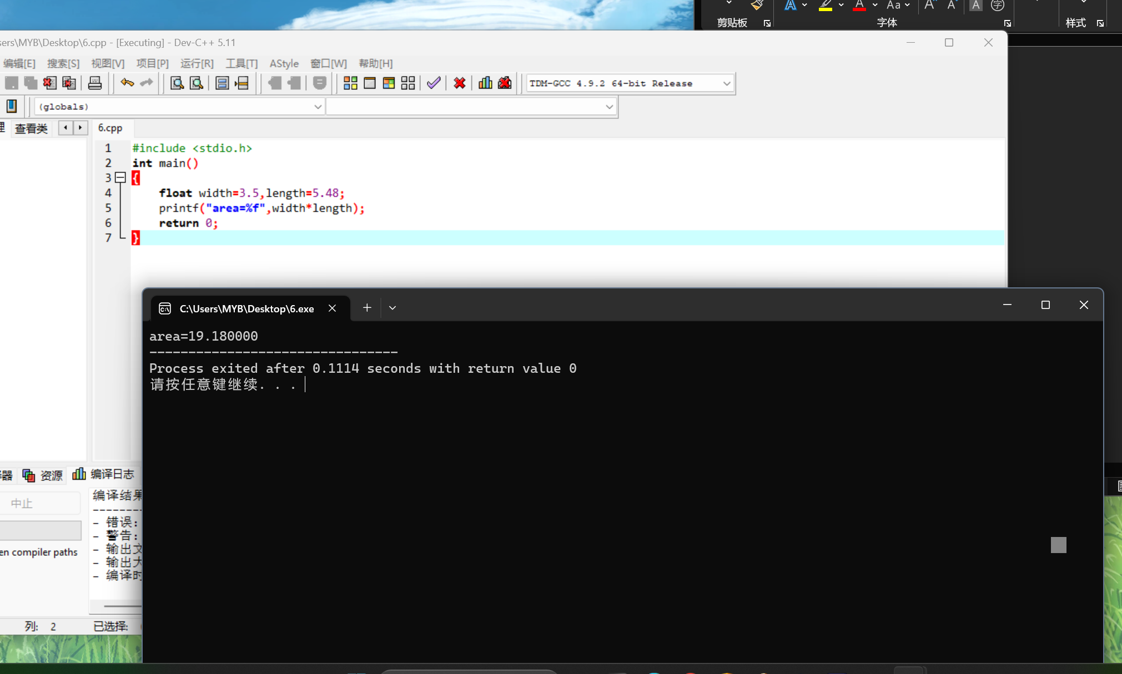

***60.3.b***

#include <stdio.h>

int main()

{

float width=3.5,length=5.48;

printf("perometer=%f",(width+length)*2);

return 0;

}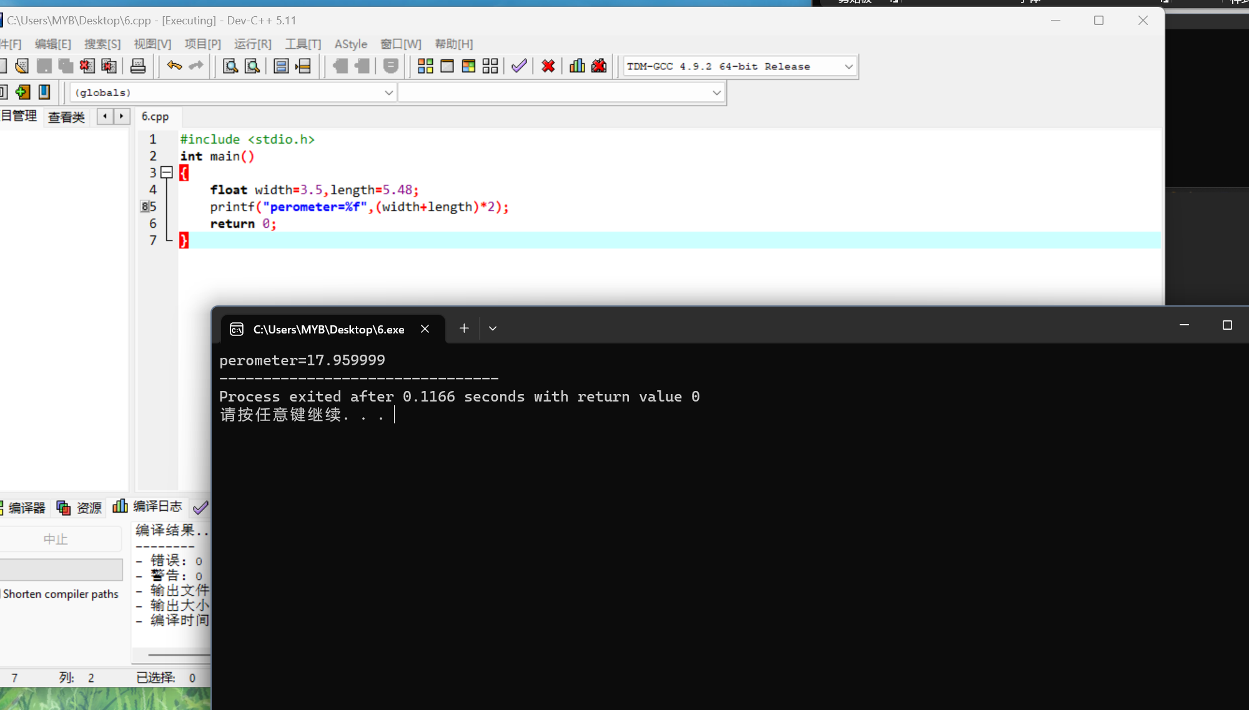

***60.4***

#include <stdio.h>

int main()

{

printf("The minutes in a leap year are %d\nAnd the minutes in a normal year are %d",366*24*60,365*24*60);

return 0;

}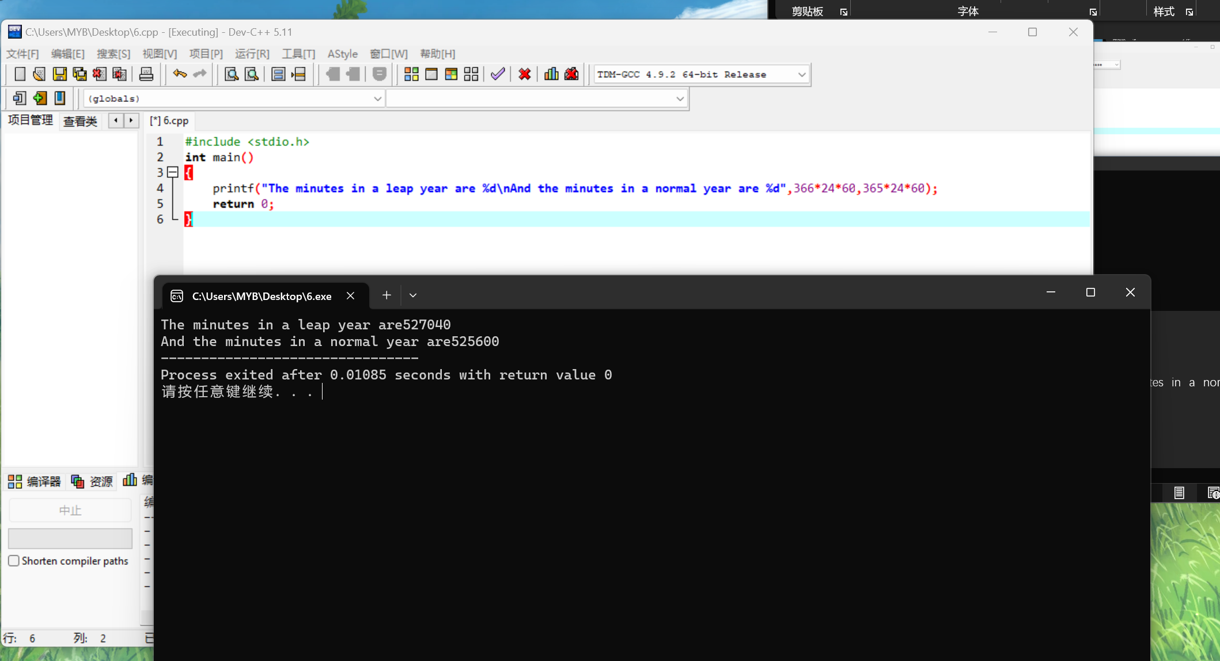

***60.5***

#include <stdio.h>

int main()

{

int laptop=889;

float discount=0.6;

printf("The total purchase price is %f",laptop/discount);

return 9;

}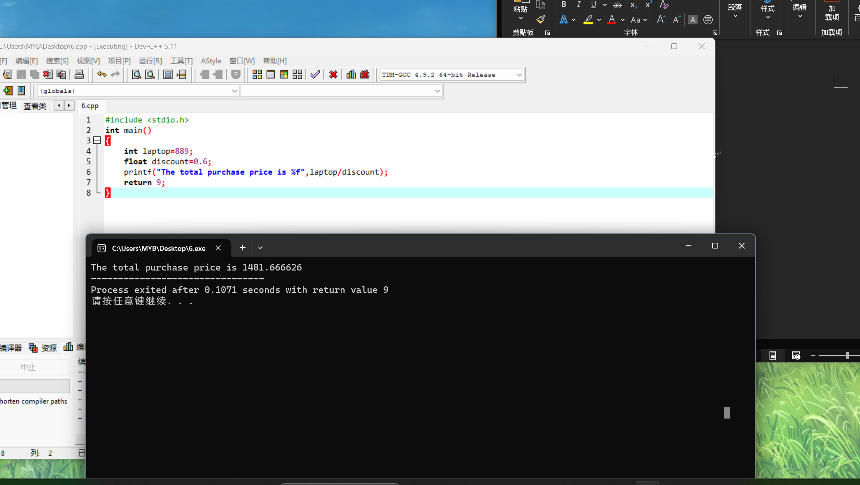

***60.6.a***

#include <stdio.h>

int main()

{

float paid=10,check=6.07;

int change,dollars ,quarters,dimes,nickels,pennies;

change=int((paid-check)*100);

dollars=change/100;

quarters=change%100/25;

dimes=change%100%25/10;

nickels=change%100%25%10/5;

pennies=change%100%25%10%5;

printf("dollars bills=%d\n quarters=%d\n dimes=%d\n nickels=%d\n pennies=%d",dollars ,quarters,dimes,nickels,pennies);

return 0;

}

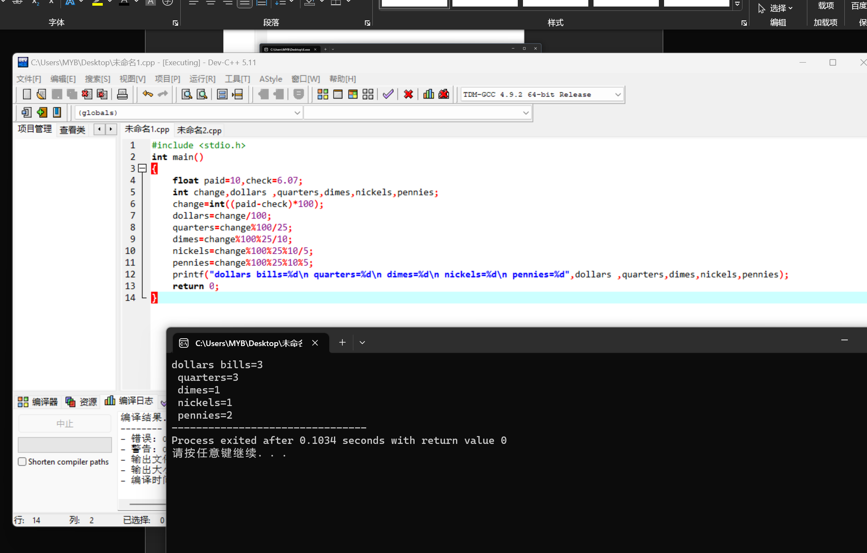

***60.6..b***

#include <stdio.h>

int main()

{

float paid=20,check=12.36;

int change,dollars ,quarters,dimes,nickels,pennies;

change=int((paid-check)*100);

dollars=change/100;

quarters=change%100/25;

dimes=change%100%25/10;

nickels=change%100%25%10/5;

pennies=change%100%25%10%5;

printf("dollars bills=%d\n quarters=%d\n dimes=%d\n nickels=%d\n pennies=%d",dollars ,quarters,dimes,nickels,pennies);

return 0;

}

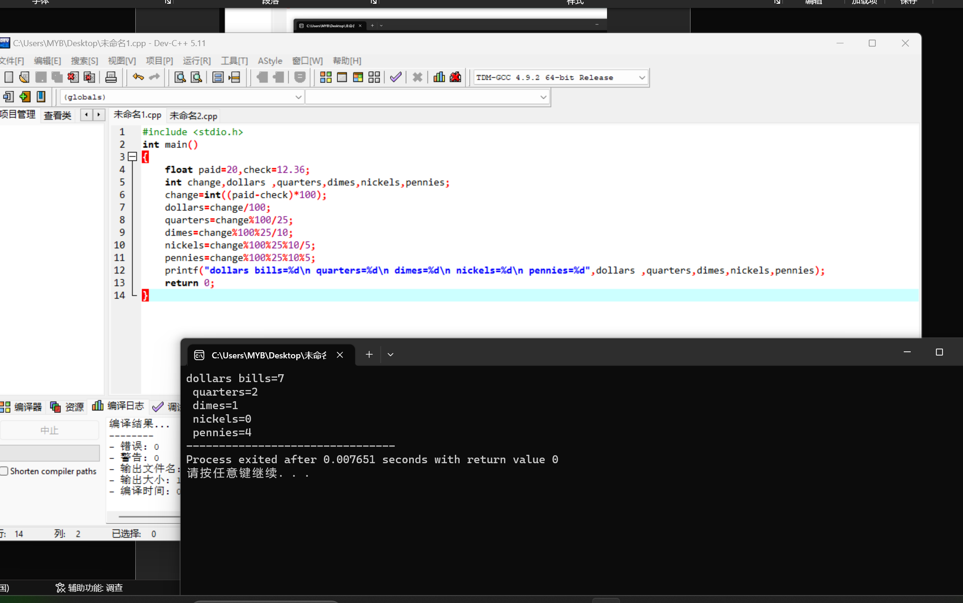

***61.7***

#include <stdio.h>

int main()

{

int num1=15,num2=18,total;

float average;

total=num1+num2;

average=total/2.0;

printf("total=%d\navergae=%f",total,average);

return 0;

}